Understanding XML

You’ll find that the basics are not that difficult, although some people seem determined to make XML harder than it has to be. XML is just human-readable data combined with human-readable metadata. That is, XML files contain regular text, so you can read them. And they contain both data (such as customer ID values) and descriptions of that data.
Here’s a concrete example to start with. This XML file represents data for two customers:

<?xml version=”1.0” encoding=”UTF-8”?>
<!-- Customer list for Bob’s Tractor Parts -->
<Customers>
<Customer CustomerNumber=”1”>
<CustomerName>Lambert Tractor Works
</CustomerName>
<CustomerCity>Millbank</CustomerCity>
<CustomerState>WA</CustomerState>
</Customer>
<Customer CustomerNumber=”2”>
<CustomerName><![CDATA[Joe’s Garage]]>
</CustomerName>
<CustomerCity>Doppel</CustomerCity>
<CustomerState>OR</CustomerState>
</Customer>
</Customers>

Even without knowing anything about XML, you can see some things just by looking at this file. In particular, XML consists of tags (which are contained within angle brackets) and data. Tags appear in pairs, with each opening tag matched by a closing tag. The closing tag has the same text as the opening tag, prefixed with a forward slash (for example, if <CustomerCity> is the opening tag, </CustomerCity> is the closing tag.
The first thing that you find in an XML file is the XML declaration:
<?xml version=”1.0” encoding=”UTF-8”?>
The declaration tells you three things about this document:
- It’s an XML document.
- It conforms to the XML 1.0 specification.
- It uses the UTF-8 character set (a standard set of characters for the Western alphabet).
The XML tags that begin and end with a ? are called processing instructions. Tags in an XML document contain the names of elements.
If you’re familiar with Hypertext Markup Language (HTML), you know that in HTML, some elements have names dictated by the HTML specification. For example, the <H1> tag specifies a first-level heading. XML takes a different approach. You can make up any name you like for an element, subject to some simple naming rules:
- A name can contain any alphanumeric character.
- A name can contain underscores, hyphens, and periods.
- A name must not contain any whitespace.
- A name must start with a letter or an underscore.
An opening tag together with a closing tag and the content between them define an element. For example, here’s a single element from the sample document:
<CustomerState>OR</CustomerState>
This defines an element whose name is CustomerState and whose value is OR.
Elements can be nested, but they cannot overlap. So the following is legal XML, defining an element named Customer that has three child elements:
<Customer CustomerNumber=”1”>
<CustomerName>Lambert Tractor Works</CustomerName>
<CustomerCity>Millbank</CustomerCity>
<CustomerState>WA</CustomerState>
</Customer>

But the following is not legal XML because the CustomerCity and CustomerState elements overlap:
<Customer CustomerNumber=”1”>
<CustomerName>Lambert Tractor Works</CustomerName>
<CustomerCity>Millbank<CustomerState>
</CustomerCity>WA</CustomerState>
</Customer>
Every XML document contains a single root element that contains all the other nodes of the XML document. The root element in the sample document is named Customers.
The effect of the rules that nesting is okay, overlapping is not okay, and there is a single root element is that any XML document can be represented as a tree of nodes.
Elements can contain attributes. An attribute is a piece of data that further describes an element. For example, the sample document includes this opening tag for an element:
<Customer CustomerNumber=”1”>
This declares an element named Customer. The Customer element includes an attribute whose name is CustomerNumber and whose value is 1.
An XML document can contain one or more namespace declarations.
The sample document does not declare a namespace. Here’s an example for a namespace declaration:
<Customers xmlns:tr=”urn:schemas-tractor-repair”>
The namespace is declared as part of the root tag for the document.
In this particular case, the namespace (introduced with the special xmlns characters) defines the prefix tr for tags within the namespace. urn (for the uniform resource name) is an arbitrary string whose purpose is to distinguish this namespace from other namespaces.
XML namespaces serve the same purpose as .NET namespaces:
They help cut down on naming collisions. After declaring the tr namespace, an XML document could use a tag such as this:
<tr:CustomerState>OR</tr:CustomerState>
This indicates that this CustomerState tag is from the tr namespace and should not be confused with any other CustomerState tag.
XML offers two ways to deal with special characters in data. First, for individual characters you can use entity references. Five entity references are defined in the XML standard:
- &lt—Translates to < (opening angle bracket).
- &gt—Translates to > (closing angle bracket).
- &amp—Translates to & (ampersand).
- &apos—Translates to ‘ (apostrophe)
- &quot—Translates to “ (quotation mark).
You can also use a CDATA section to hold any arbitrary data, whether the data contains special characters or not. The sample document uses this approach to store a customer name containing an apostrophe, as shown here:
<CustomerName><![CDATA[Joe’s Garage]]></CustomerName>
Finally, an XML document can contain comments. Comments are set off by the opening string <!-- and the closing string -->. Here’s an example:
<!-- Customer list for Bob’s Tractor Parts -->
There is a great deal more complexity available in XML than discussed in this section. But these basics are more than enough for you to understand most of the XML that you’re likely to run across until you start working with XML in depth.

Using the XmlNode, XmlDocument,

XmlTextReader, and XmlTextWriter Classes

XML documents on disk are just disk files, so you could read them with the System.IO classes.
But XML is so central to the .NET Framework that the .NET Framework provides classes especially for working with XML. These classes are grouped together in the System.Xml namespace.
To understand the .NET Framework representation of an XML document, you can start with the concept of a node. A node is one item in an XML document: It might be an attribute, a comment, an element, or something else. In the System.Xml namespace, nodes are represented by XmlNode objects. The following table shows the most important members of the XmlNode object.

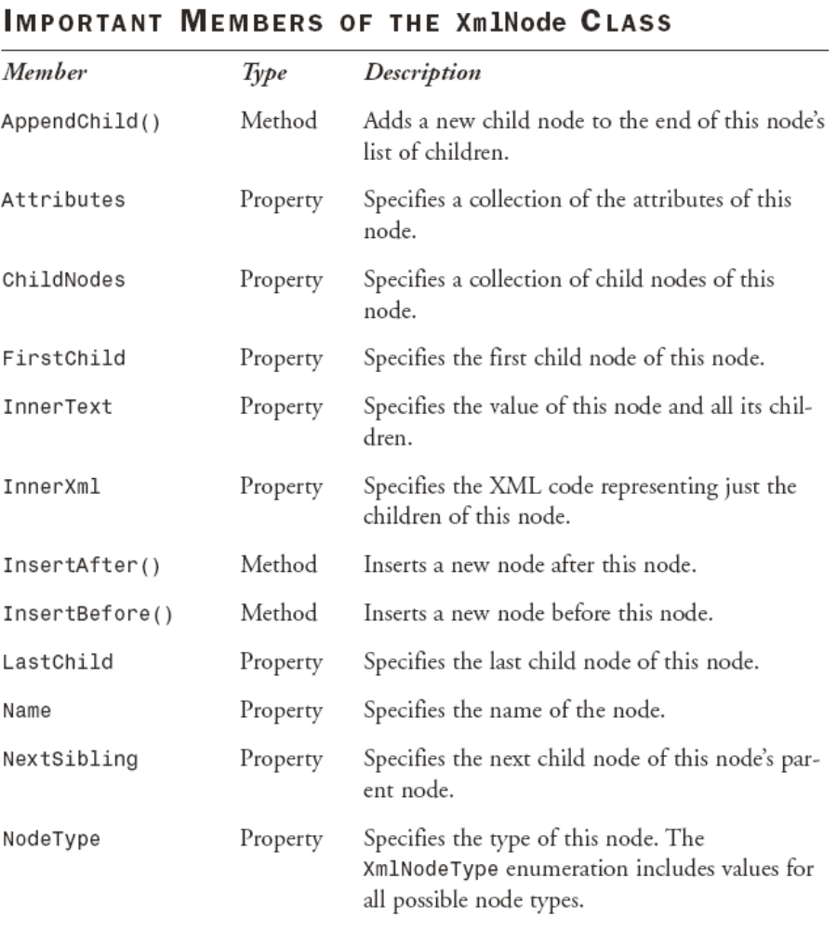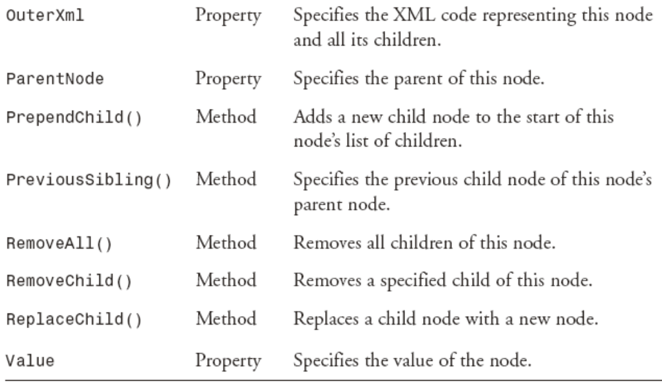

XmlNode objects are collected into an XmlDocument object. As you can probably guess, XmlDocument is the object in the System.Xml namespace that represents an entire XML document. The XmlDocument class provides an in-memory representation of an XML document.
The XmlDocument class implements the W3C Document Object Model (DOM) Level 1 Core and the Core DOM Level 2 standards. The DOM provides a standard programming model for working with XML. The following table shows the most important members of the XmlDocument class.

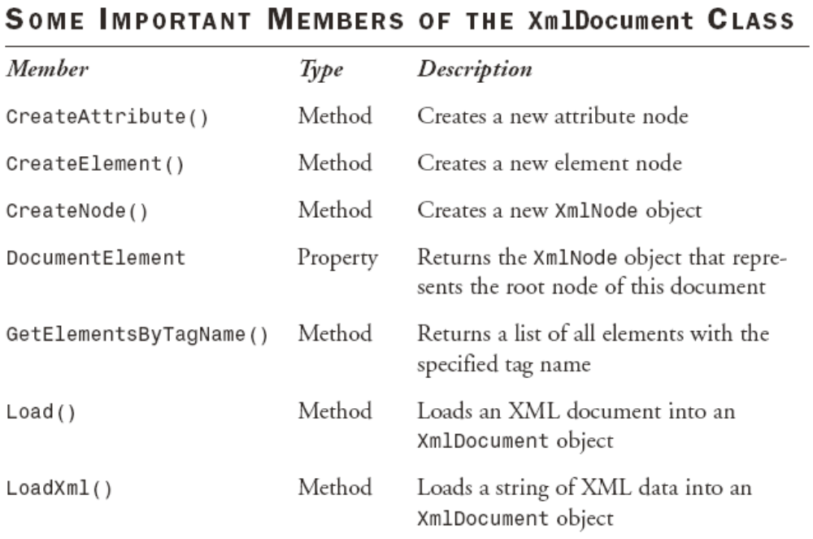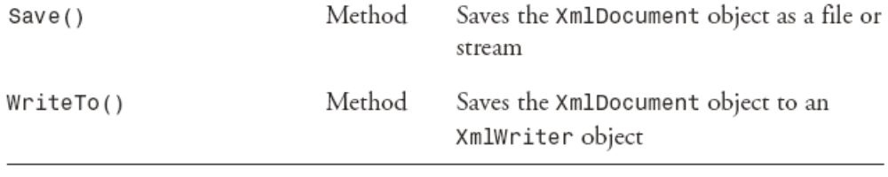

Lab 12: Displaying the Contents of an XML Document

1. Add a new form to your Visual C# .NET project.
2. Place a ListBox control (lbNodes) and a Button control (btnLoadXml) on the form.
3. Switch to the code view and add the following using directive:
using System.Xml;
4. Double-click the Button control and enter this code to load data when the button is clicked:
private void btnLoadXml_Click(object sender,
System.EventArgs e)
{
// Browse for an XML file
OpenFileDialog dlgOpen = new OpenFileDialog();
dlgOpen.Title = “Select a File”;
dlgOpen.Filter =
“XML files (*.xml)|*.xml|All Files(*.*)|*.*”;
if(dlgOpen.ShowDialog() == DialogResult.OK)
{
// Create an XmlTextReader object
// that will read in the file
XmlTextReader xtr = new XmlTextReader(
dlgOpen.FileName);
xtr.WhitespaceHandling = WhitespaceHandling.None;
// Create an XmlDocument object
XmlDocument xd = new XmlDocument();
// Load the file into the XmlDocument
xd.Load(xtr);
// Add an item representing the document
// to the ListBox
lbNodes.Items.Add(“XML Document”);
// Find the root node, and
// add it together with its children
XmlNode xnod = xd.DocumentElement;
AddWithChildren(xnod, 1);
}
}
private void AddWithChildren(
XmlNode xnod, Int32 intLevel)
{
// Adds a node to the ListBox, together with its
// children. intLevel controls the
// depth of indenting
XmlNode xnodWorking;
String strIndent = new String(‘ ‘, 2 * intLevel);
// Get the value of the node (if any)
String strValue= (String) xnod.Value;
if(strValue != null)
{
strValue = “ : “ + strValue;
}
// Add the node details to the ListBox
lbNodes.Items.Add(strIndent + xnod.Name + strValue);
// For an element node, retrieve the attributes
if(xnod.NodeType == XmlNodeType.Element)
{
XmlNamedNodeMap mapAttributes= xnod.Attributes;
// Add the attrbutes to the ListBox
foreach(XmlNode xnodAttribute in mapAttributes)
{
lbNodes.Items.Add(strIndent + “ “ +
xnodAttribute.Name + “ : “ +
xnodAttribute.Value);
}
// If there are any child nodes
// Call this procedure recursively
if(xnod.HasChildNodes)
{
xnodWorking = xnod.FirstChild;
while (xnodWorking != null)
{
AddWithChildren(
xnodWorking, intLevel + 1);
xnodWorking = xnodWorking.NextSibling;
}
}
}
}
5. Run the project. Click the button and browse to an XML file (for example, Customers.xml). The contents of the XML code are dumped to the ListBox control, as shown in Figure 12.
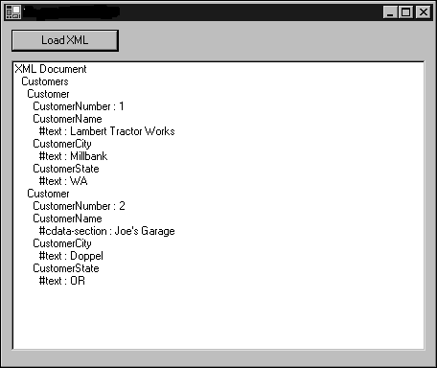
FIGURE 12
The XmlDocument class is an in-memory representation of an XML document.
As you can see in Figure 12, the object model implemented in the XmlDocument and XmlNode objects has access to the entire contents of the XML file. The code in Lab 12 uses an XmlTextReader object to read the disk file into the XmlDocument object. The XmlTextReader object has very similar functionality to the StreamReader and BinaryReader objects, except that it’s designed to pipe data from a disk file to an XmlDocument object. The XmlTextReader object also has other XMLspecific features. For example, the WhitespaceHandling property setting in the code in Lab 12 tells it not to create nodes for extra whitespace in the XML file.
The code uses the DocumentElement property of the XmlDocument object to find the node at the root of the tree representation of the XML document.
After that, it’s just a matter of recursively calling a procedure that adds information about the node to the ListBox control.
One bit of added complexity in the code is necessary to deal with attributes. Attribute nodes are not included in the ChildNodes collection of a node in the XmlDocument object. Instead, you can use the
Attributes property of the XmlNode object to get a collection of attribute nodes only. The code uses an XmlNamedNodeMap object to hold this collection; this object can hold an arbitrary collection of XmlNode objects of any type.
You can also modify an XML document through the XmlDocument object. To do so, you need to modify the individual XmlNode objects and then write the file back to disk.

Lab 13: Modifying an XML File by Using Code

1. Add a new form to your Visual C# .NET project.
2. Place a Button control (btnModify) on the form.
3. Switch to the code view and add the following using directive:
using System.Xml;
4. Double-click the Button control and enter this code to load and modify data when the button is clicked:
private void btnModify_Click(object sender,
System.EventArgs e)
{
// Browse for an XML file
OpenFileDialog dlgOpen = new OpenFileDialog();
dlgOpen.Title = “Select a File”;
dlgOpen.Filter =
“XML files (*.xml)|*.xml|All Files(*.*)|*.*”;
if(dlgOpen.ShowDialog() == DialogResult.OK)
{
// Create an XmlTextReader object
// that will read in the file
XmlTextReader xtr = new XmlTextReader(
dlgOpen.FileName);
xtr.WhitespaceHandling =
WhitespaceHandling.None;
// Create an XmlDocument object
XmlDocument xd = new XmlDocument();
// Load the file into the XmlDocument
xd.Load(xtr);
xtr.Close();
// Find the root node, and
// modify it together with its children
XmlNode xnod = xd.DocumentElement;
ModifyWithChildren(xnod);
// Write the modified file to disk
XmlTextWriter xtw = new XmlTextWriter(
dlgOpen.FileName + “.new”,
System.Text.Encoding.UTF8);
xd.WriteTo(xtw);
xtw.Flush();
xtw.Close();
MessageBox.Show(“Done!”);
}
}
private void ModifyWithChildren(XmlNode xnod)
{
XmlNode xnodWorking;
if (xnod.Name == “CustomerCity”)
{
// Sets all CustomerCity nodes to uppercase
xnod.FirstChild.Value =
xnod.FirstChild.Value.ToUpper();
}
// If there are any child nodes
// Call this procedure recursively
if (xnod.HasChildNodes)
{
xnodWorking = xnod.FirstChild;
while(xnodWorking != null)
{
ModifyWithChildren(xnodWorking);
xnodWorking = xnodWorking.NextSibling;
}
}
}
5. Run the project. Click the button and browse to an XML file. The code makes a copy of the XML file with the added extension .new. The copy has all the CustomerCity values converted to uppercase.
Writing the XML file in Lab 13 uses one new class, XmlTextWriter. This class connects an XmlDocument object to a backing store for output.

Treating XML as Relational Data

You can treat an XML document as relational data. To do this, you can use the XmlDataDocument class, which inherits from XmlDocument.
The key feature of the XmlDataDocument class is that it can be synchronized with a DataSet object.

Lab 14: Reading an XML Document into a DataSet Object

1. Add a new form to your Visual C# .NET project.
2. Place a Button control (btnLoadXml) and a DataGrid control (dgXml) on the form.
3. Switch to the code view and add the following using directives:
using System.Xml;
using System.Data;
4. Double-click the Button control and enter this code to load data when the button is clicked:
private void btnLoadXml_Click(object sender,
System.EventArgs e)
{
// Browse for an XML file
OpenFileDialog dlgOpen = new OpenFileDialog();
dlgOpen.Title = “Select a File”;
dlgOpen.Filter =
“XML files (*.xml)|*.xml|All Files(*.*)|*.*”;
if (dlgOpen.ShowDialog() == DialogResult.OK)
{
// Create an XmlTextReader object
// that will read in the file
XmlTextReader xtr = new XmlTextReader(
dlgOpen.FileName);
// Create an XmlDocument object
XmlDataDocument xdd = new XmlDataDocument();
// Get the DataSet
DataSet ds = xdd.DataSet;
// Read the schema of the file to
// initialize the DataSet
ds.ReadXmlSchema(xtr);
xtr.Close();
xtr = new XmlTextReader(dlgOpen.FileName);
xtr.WhitespaceHandling = WhitespaceHandling.None;
// Load the file into the XmlDataDocument
xdd.Load(xtr);
xtr.Close();
// And display it on the DataGrid
dgXml.DataSource = ds;
}
}
5. Run the project. Click the button and browse to an XML file. The code loads the XML file into the DataSet object and displays it on the user interface, as shown in Figure 13.

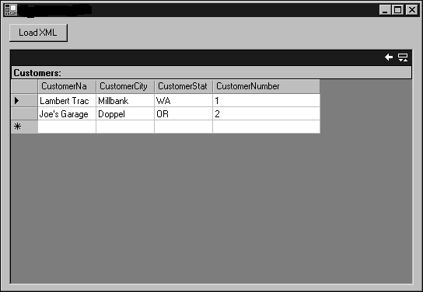
FIGURE 13
An XML File can be synchronized with a DataSet object, with the help of the XmlDataDocument class.

For the DataSet object to properly represent the XML code, it must have the same schema as the XML file. In Lab 13 I’ve ensured that by using the ReadXmlSchema() method of the DataSet object to load the schema from the same XML file that the XmlDataDocument object holds. The XmlTextReader object has to be closed and reopened after the schema is read because it’s a forwardonly object.
The synchronization between the XmlDataDocument object and the DataSet object is two way. If you derive a DataSet object from an XmlDataDocument object, modify the DataSet object, and then write the XmlDataDocument object back to disk, the changes that you made in the DataSet object are reflected in the XML file.

Lab 14:

Northwind Traders has a new European partner that doesn’t use Microsoft SQL Server for its data storage. However, it can import an XML file to its system. In this exercise, you need to retrieve all the customers from France, allow the user to edit the customer information on a form, and then save the edited version as an XML file.
The edits should not be saved to your own database.
How would you design such a form?
You should try working through this problem on your own first. If you get stuck, or if you’d like to see one possible solution, follow these steps:

1. Add a new form to your Visual C# .NET project.
2. Place a DataGrid control (dgCustomers) and a Button control (btnSave) on the form.
3. Switch to the code view and add the following using directives:
using System.Data;
using System.Data.SqlClient;
using System.Xml;
4. Double-click the form and enter this code to load the data when the form is opened:
private void Lab14_Load(
object sender,
System.EventArgs e)
{
// Create a SqlConnection
SqlConnection cnn = new SqlConnection(
“Data Source=(local);” +
“Initial Catalog=Northwind;" +
"Integrated Security=SSPI”);
// Create a SqlCommand
SqlCommand cmd = cnn.CreateCommand();
cmd.CommandType = CommandType.Text;
cmd.CommandText = “SELECT * FROM Customers “ +
“WHERE Country = ‘France’”;
// Set up the DataAdapter and fill the DataSet
SqlDataAdapter da = new SqlDataAdapter();
da.SelectCommand = cmd;
DataSet ds = new DataSet();
da.Fill(ds, “Customers”);
// Show the data on the user interface
// so that the user can edit it
dgCustomers.DataSource = ds;
dgCustomers.DataMember = “Customers”;
}

5. Double-click the Button control and enter this code to save the file when the user clicks the button:
private void btnSave_Click(object sender,
System.EventArgs e)
{
// Create an XmlDataDocument from the DataSet
XmlDataDocument xdd = new XmlDataDocument(
(DataSet) dgCustomers.DataSource);
// And save it to a disk file
XmlTextWriter xtw = new XmlTextWriter(
@”c:\temp\FranceCust.xml”,
System.Text.Encoding.UTF8);
xdd.WriteTo(xtw);
xtw.Flush();
xtw.Close();
MessageBox.Show(
@”Wrote file c:\temp\FranceCust.xml”);
}
6. Run the project. The French customers appear on the user interface. Edit some of the data and then click the Save button.
Open the c:\temp\FranceCust.xml file and verify that it contains the edited data.

